**SQL Project on**

**Zomato Sales**

**Analysis**

# Hello!!!

**I am Prathamesh Iswalkar, today I am going to solve some SQL questions which are related to Zomato**

# Questions

1.**What is the total amount each customer spends on zomato**

2.**How many days each customer visited zomato**

3.**What was the first product purchased by each customer**

4.**What is the most purchased item on the menu and how many times it was purchased by all the customers**

5.**Which is the most popular for each customer**

6.**Which item was purchased first by the customer after they became a member**

7.**Which item was purchased just before the customer become a member?**

8.**What is the total orders and amount spent for each member before they became a member.**

9.**If each product generates points for eg: 5rs = 2 zomato point and each product has different purchase points for eg: for p1 5rs = 1 p2 10rs = 5 pts and p3 is 5rs = 1 zomato points, so calculate points collected by each customer and for which product most points have been given till now.**

10.**In the first one year after a customer joins the gold program (including their join date) irrespective of what the customer has purchased they earn 5 zomato points for every 10rs spent who earned more 1 or 3 and what was their points earnings in their first year**

**1.What is the total amount each customer spends on zomato**

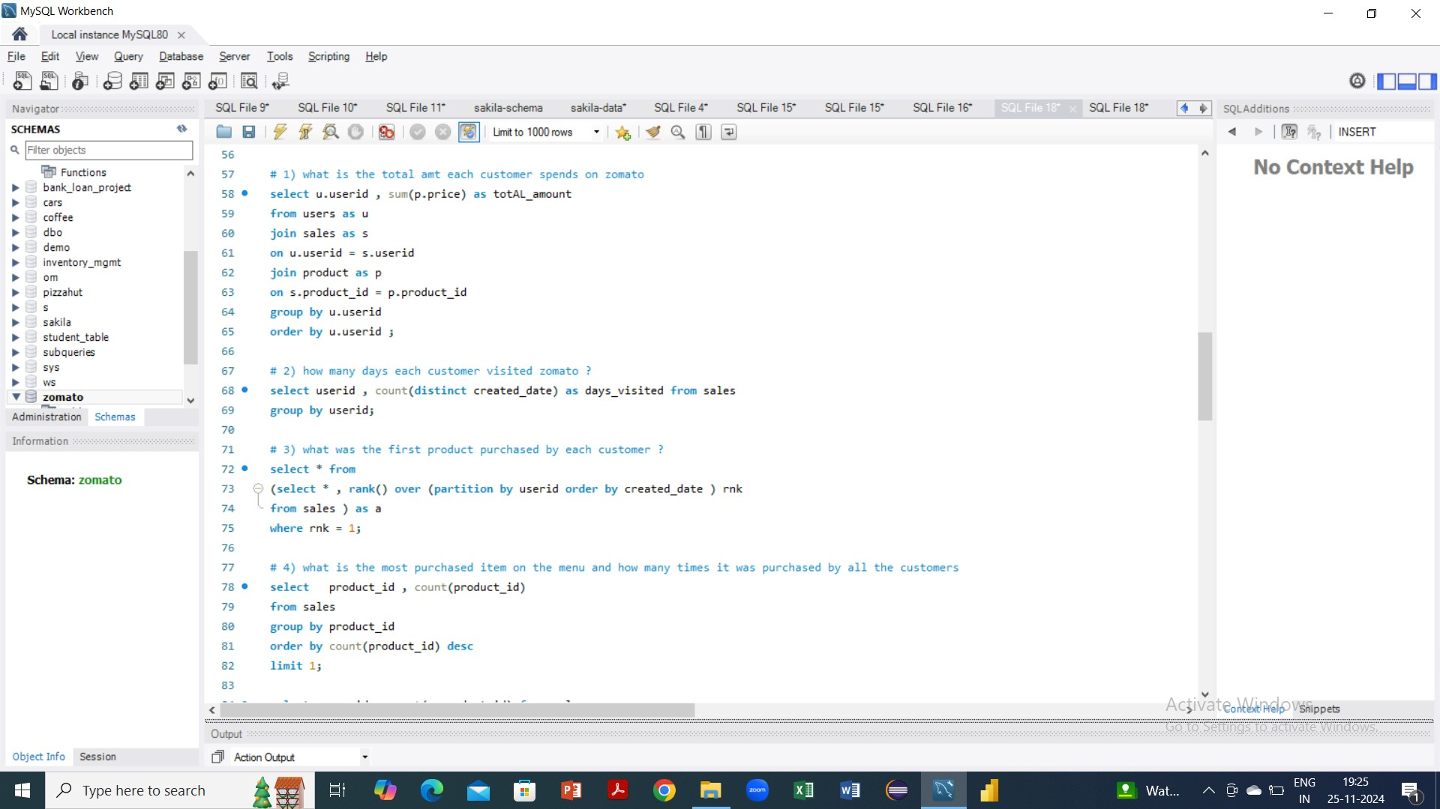

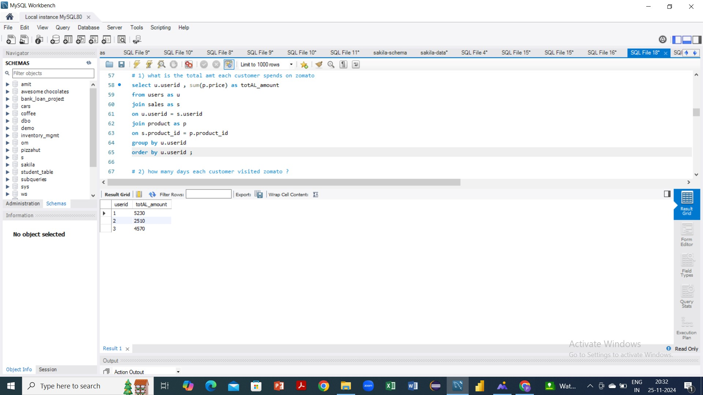

1. **How many days each customer visited zomato**



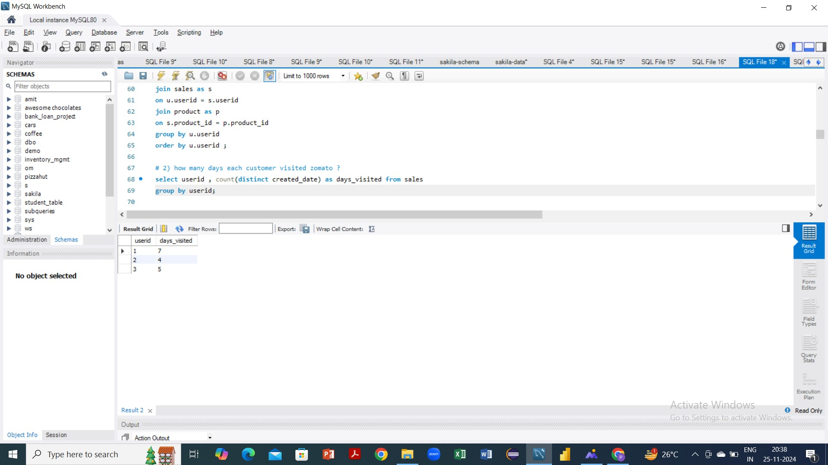

1. **What was the first product purchased by each customer**



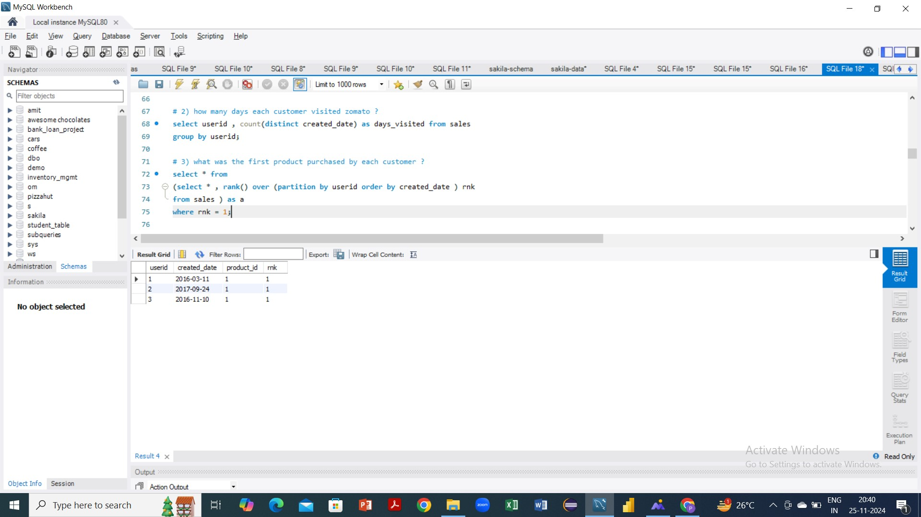

1. **What is the most purchased item on the menu and how many times it was purchased by all the customers**

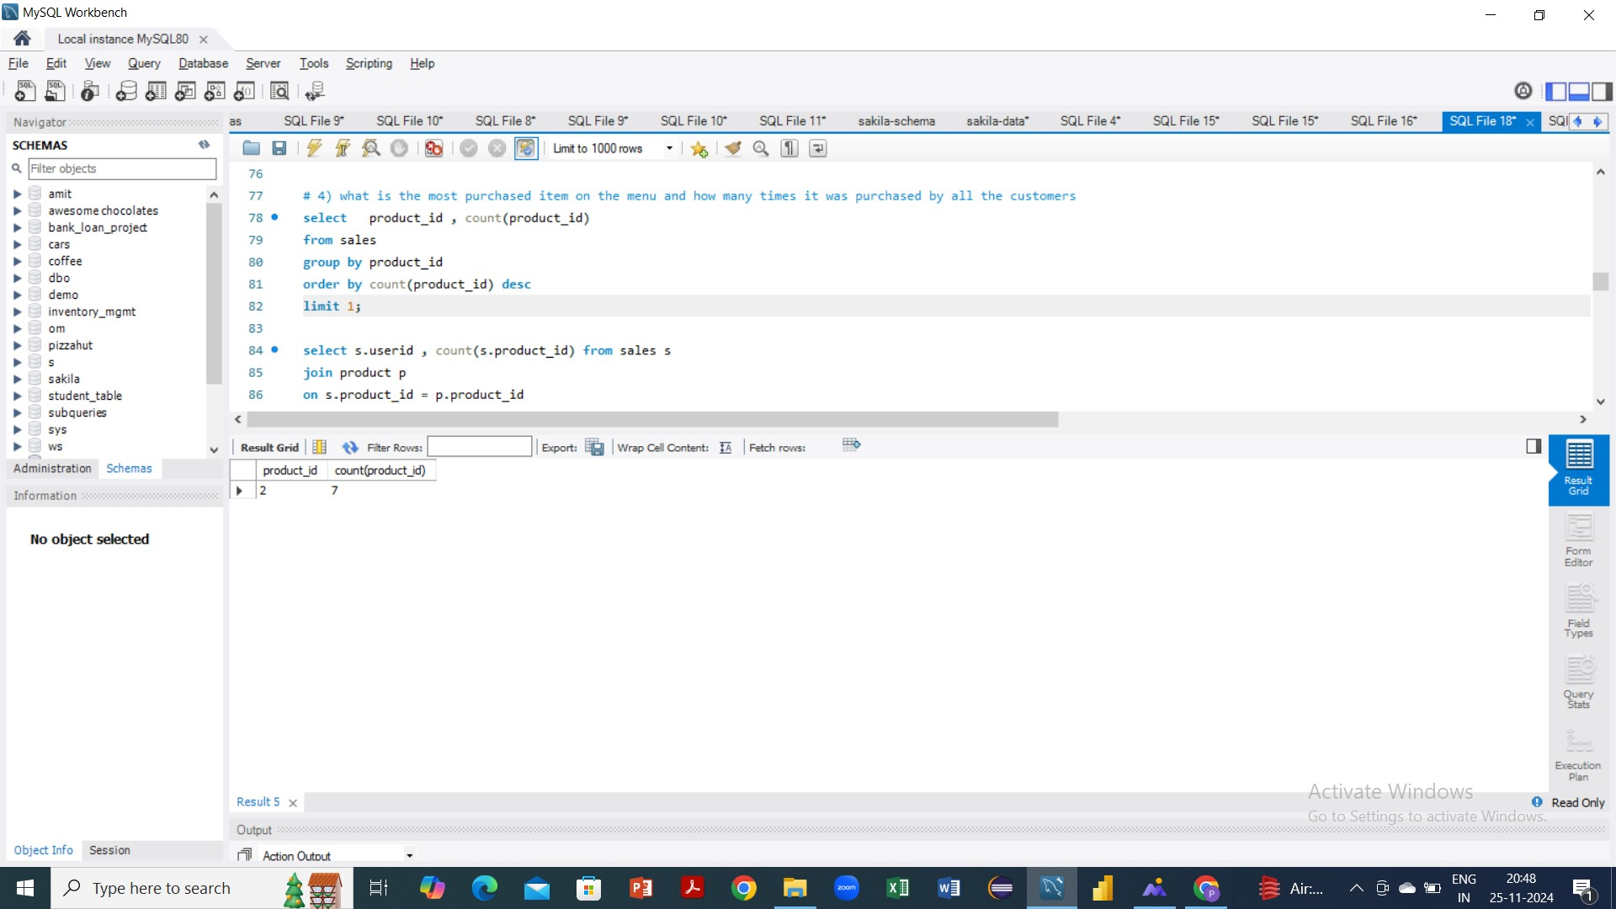

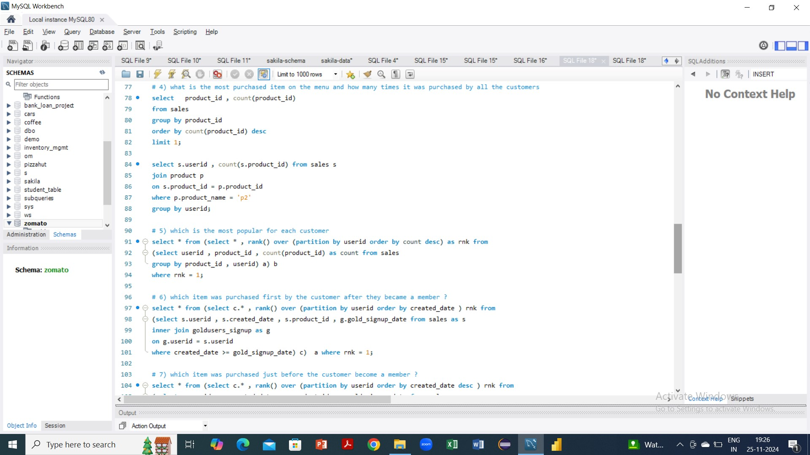

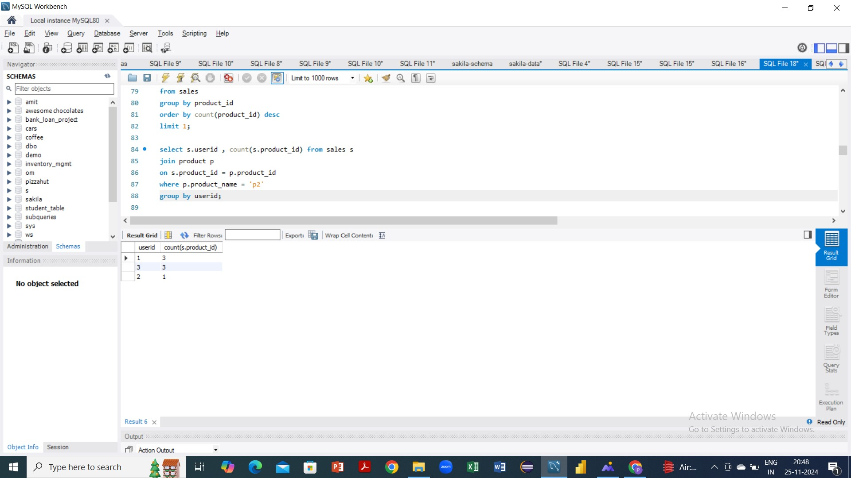

1. **Which is the most popular for each customer**



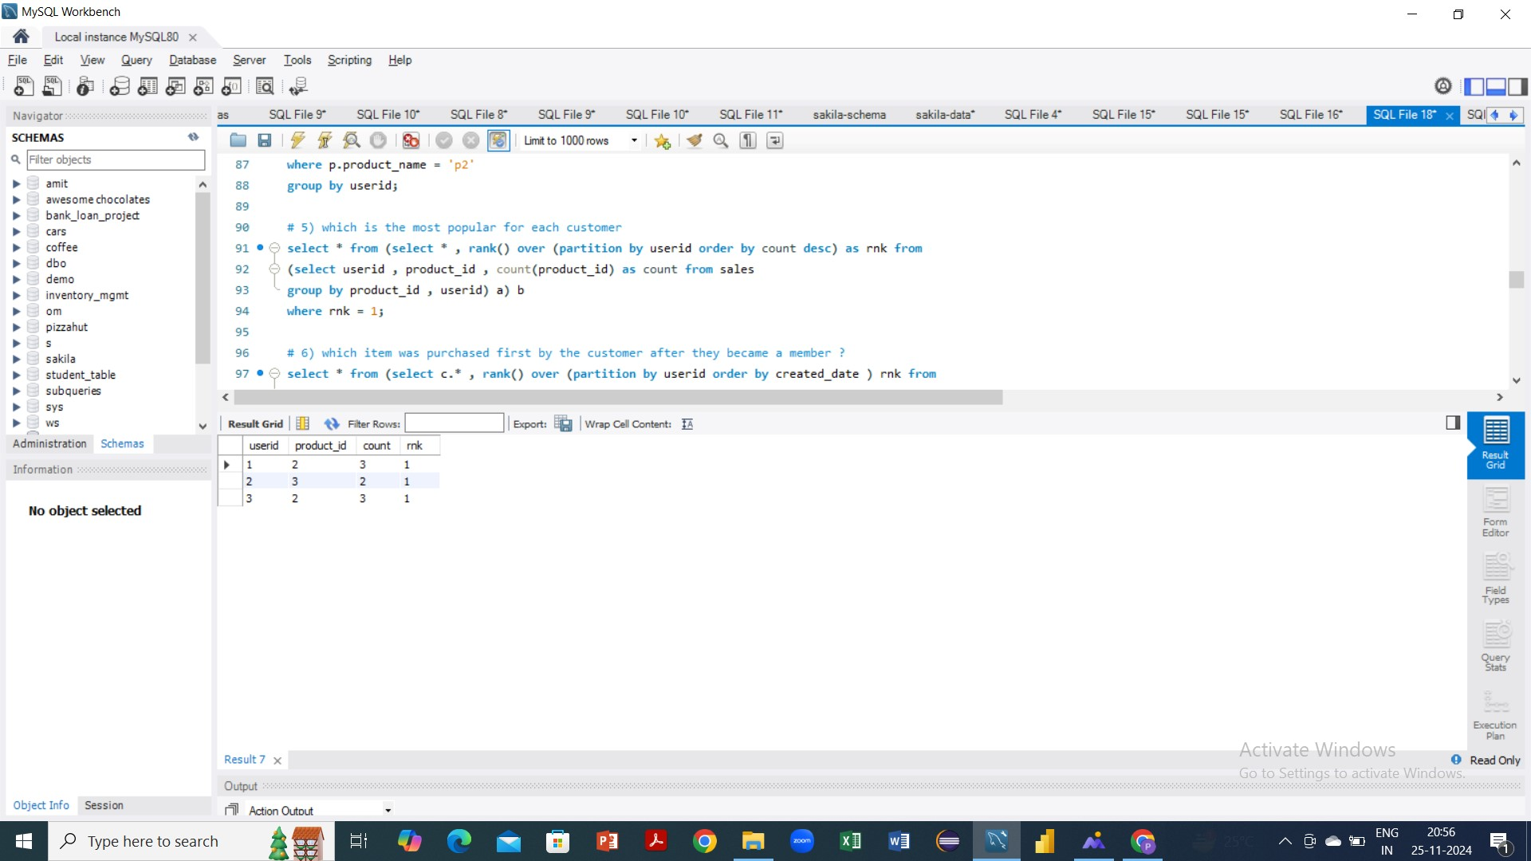

1. **Which item was purchased first by the customer after they became a member**

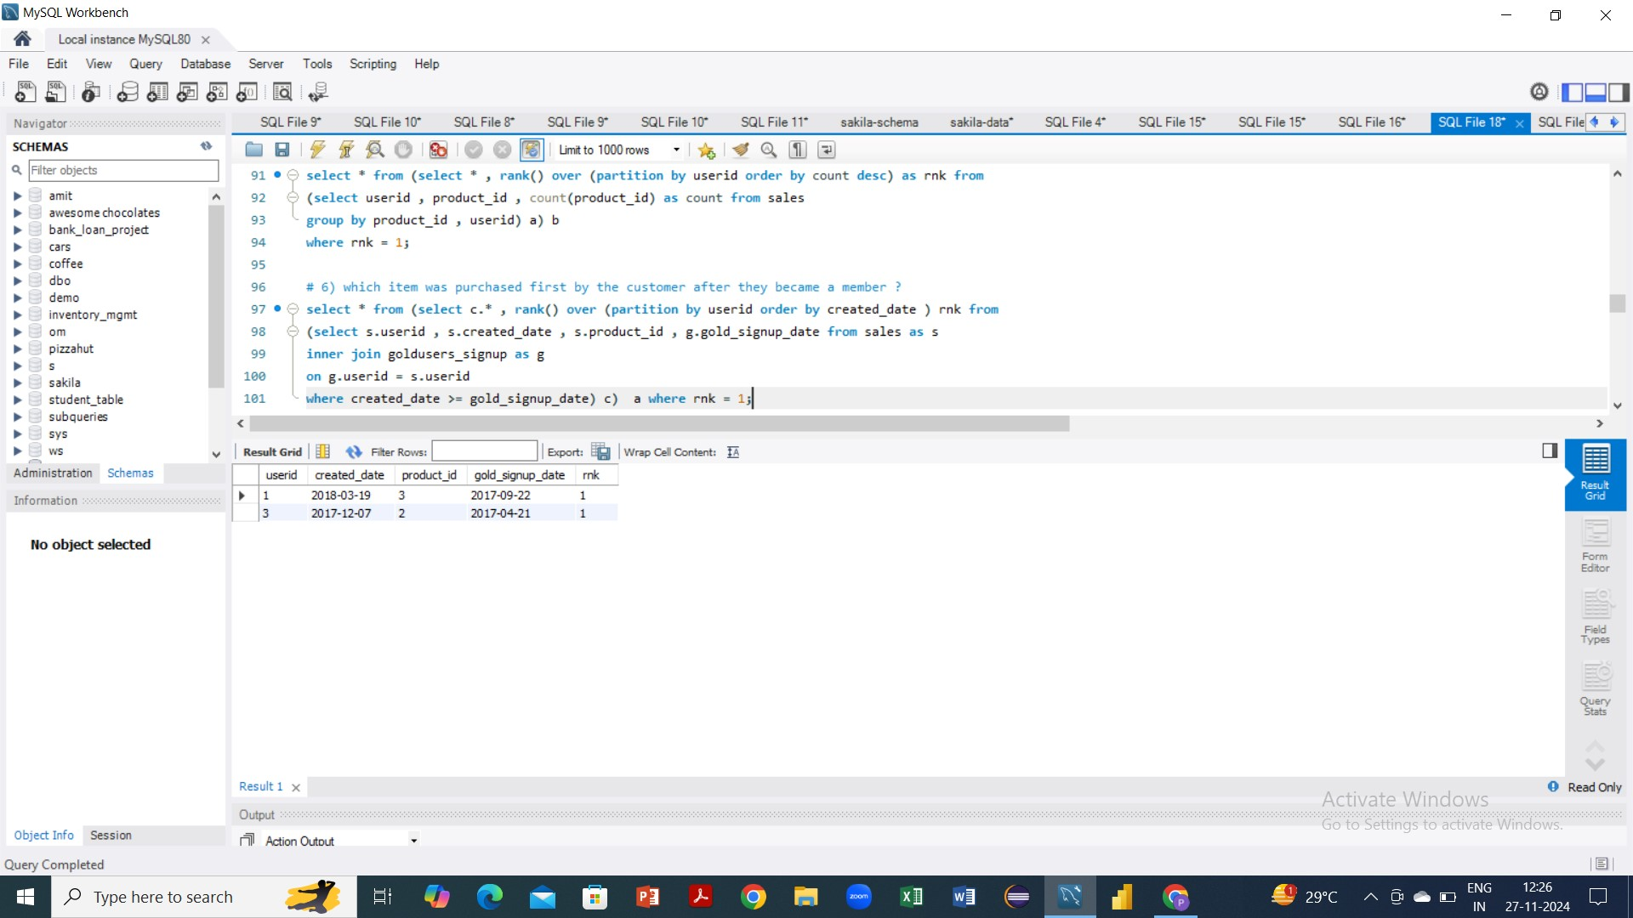



1. **Which item was purchased just before the customer become a member?**

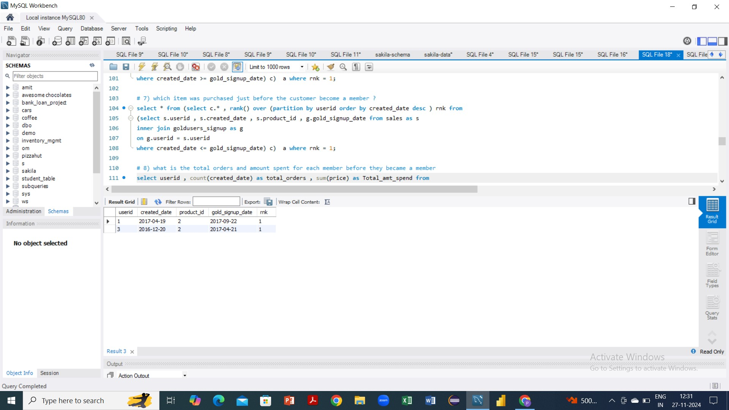



1. **What is the total orders and amount spent for each member before they became a member.**

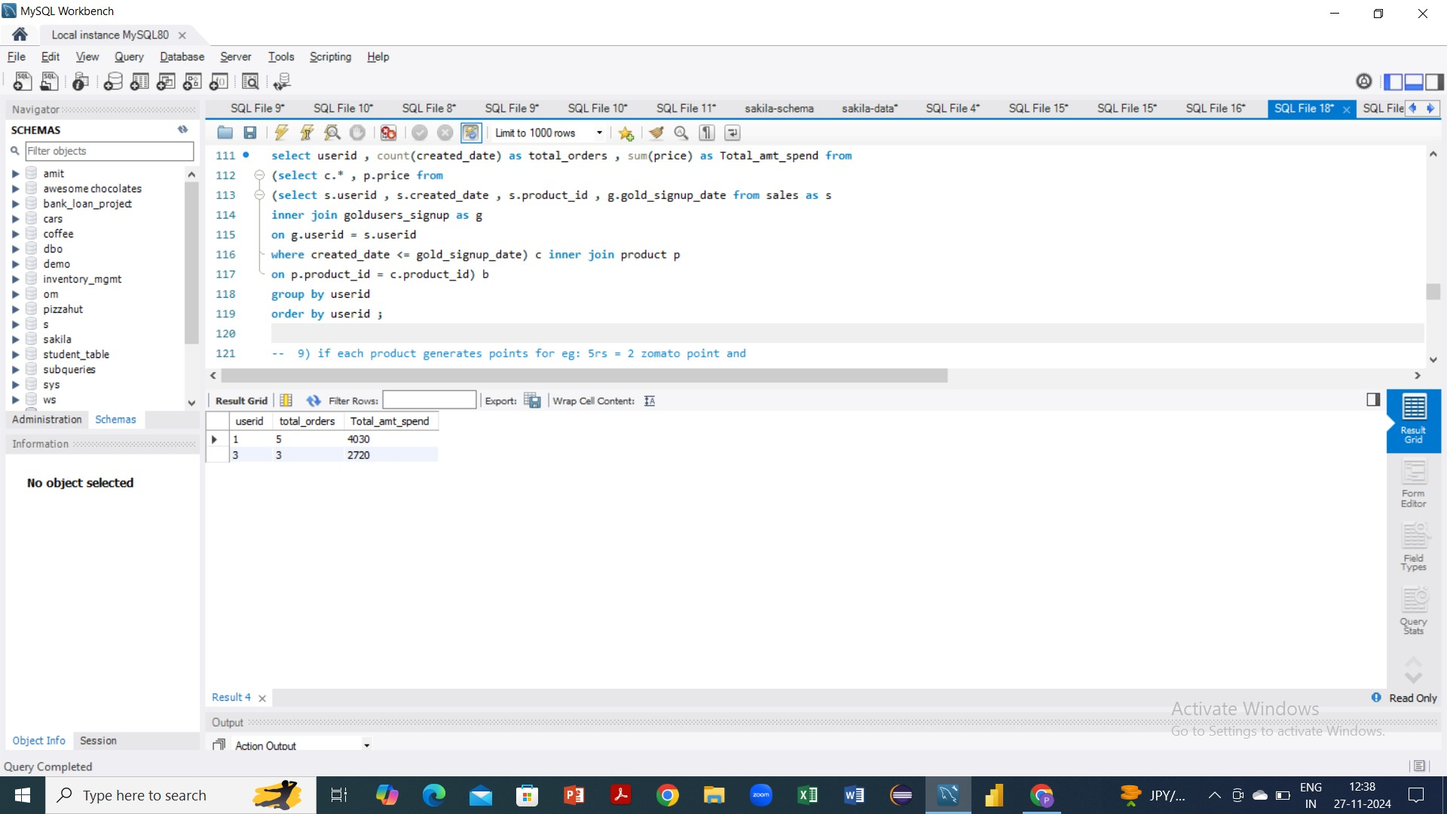



1. **If each product generates points for eg: 5rs = 2 zomato point and each product has different purchase points for eg: for p1 5rs = 1 p2 10rs = 5 pts and p3 is 5rs = 1 zomato points, so calculate points collected by each customer and for which product most points have been given till now.**

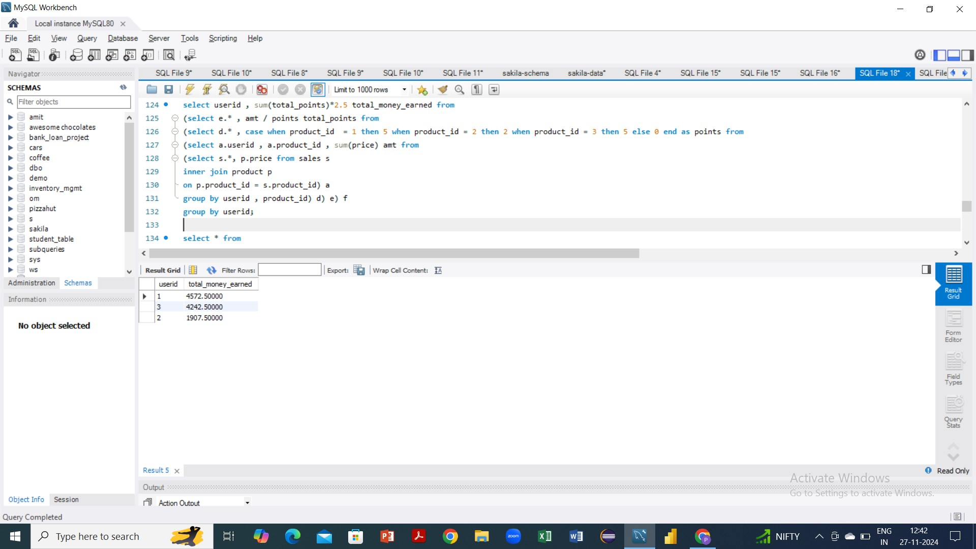 

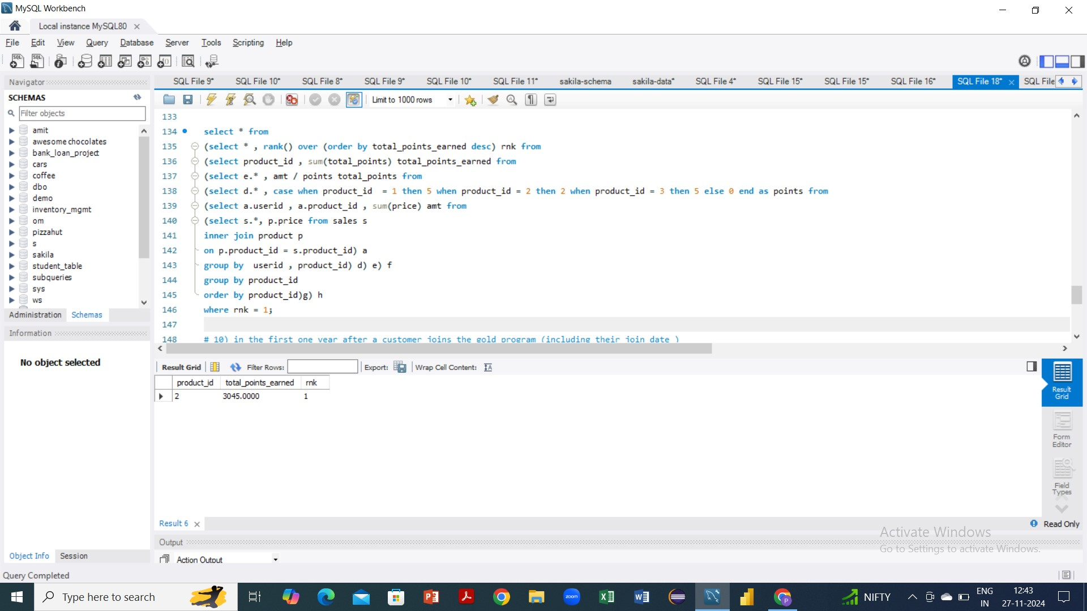 

1. **In the first one year after a customer joins the gold program (including their join date) irrespective of what the customer has purchased they earn 5 zomato points for every 10rs spent who earned more 1 or 3 and what**

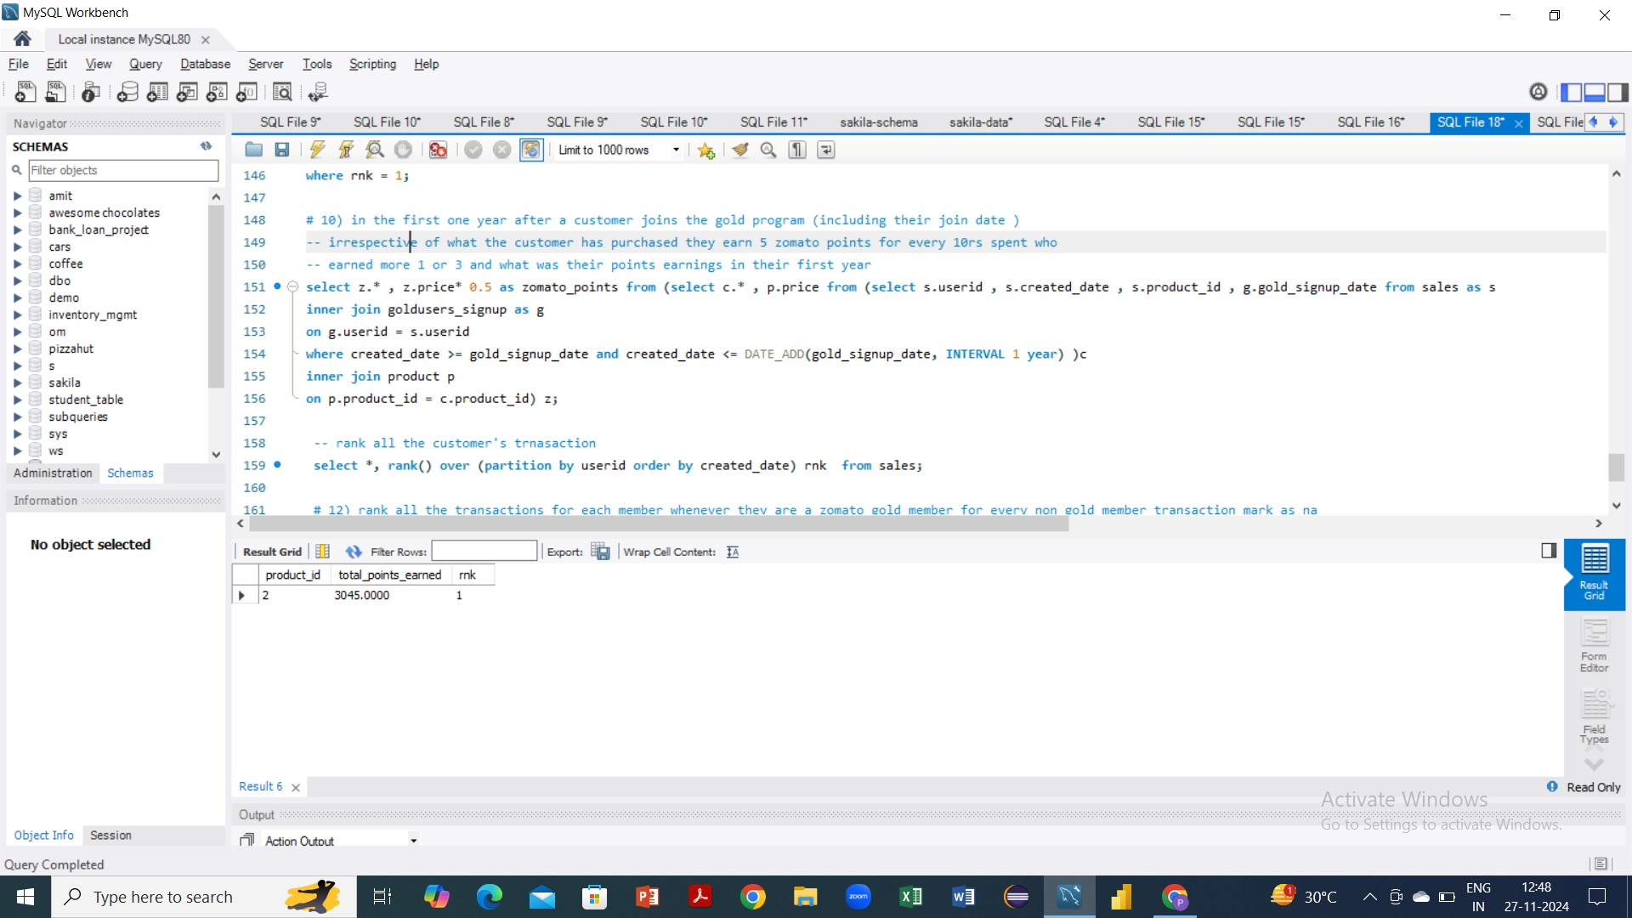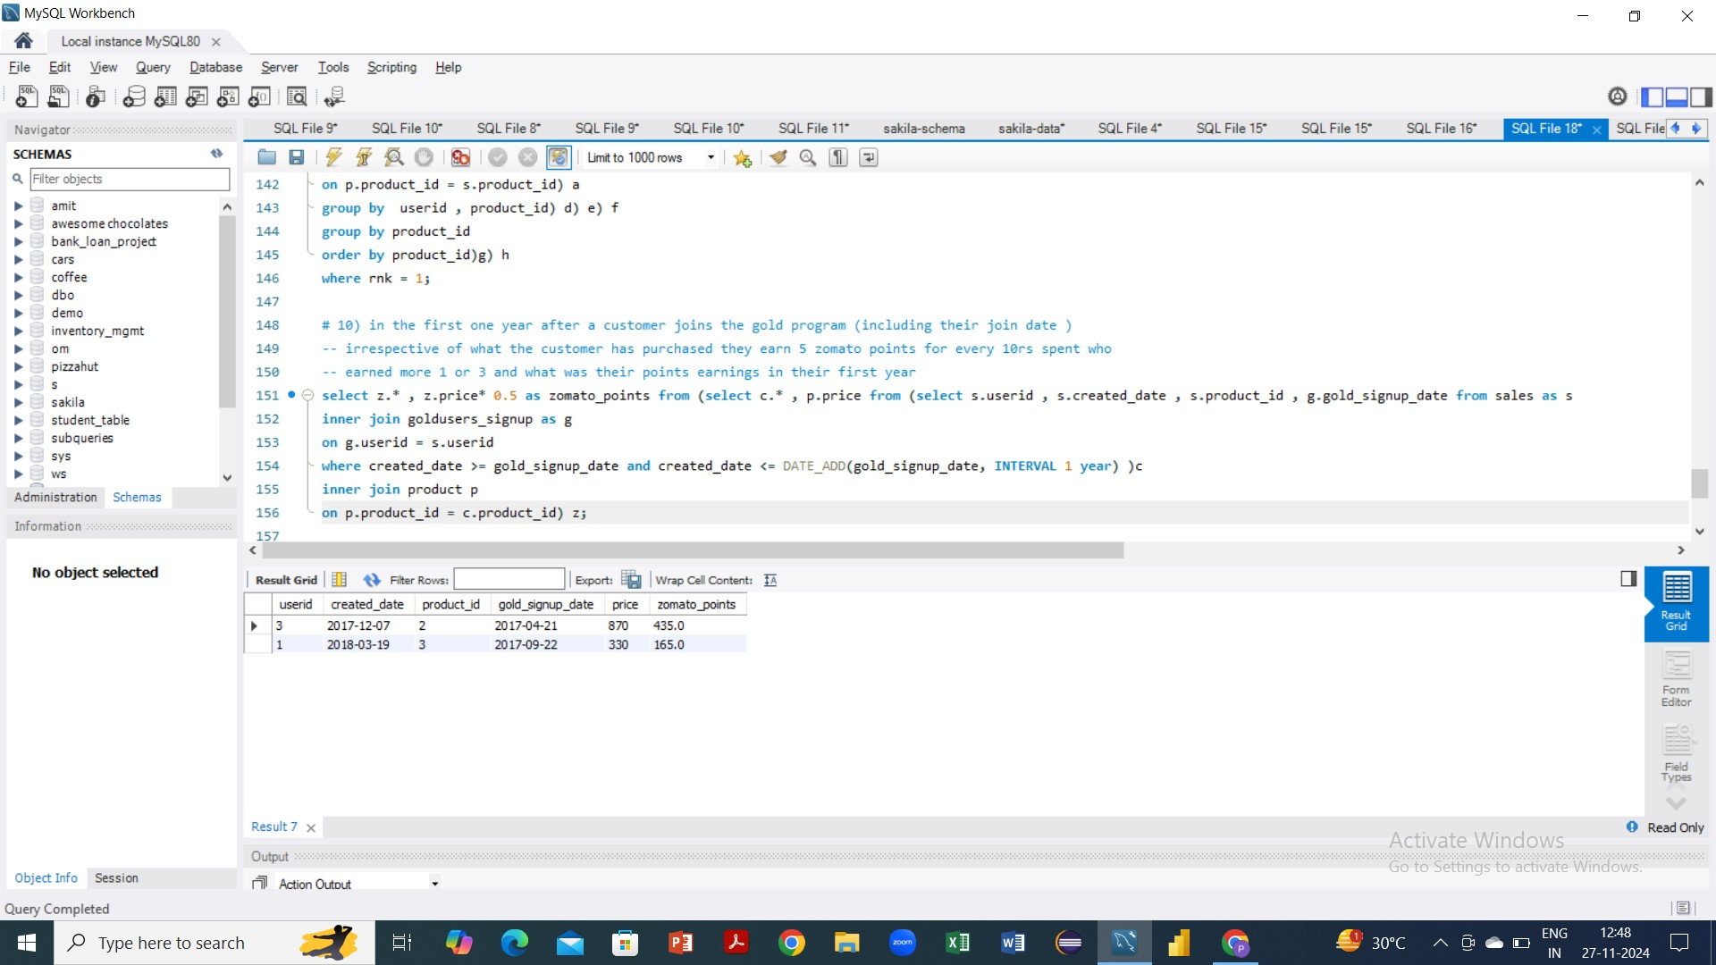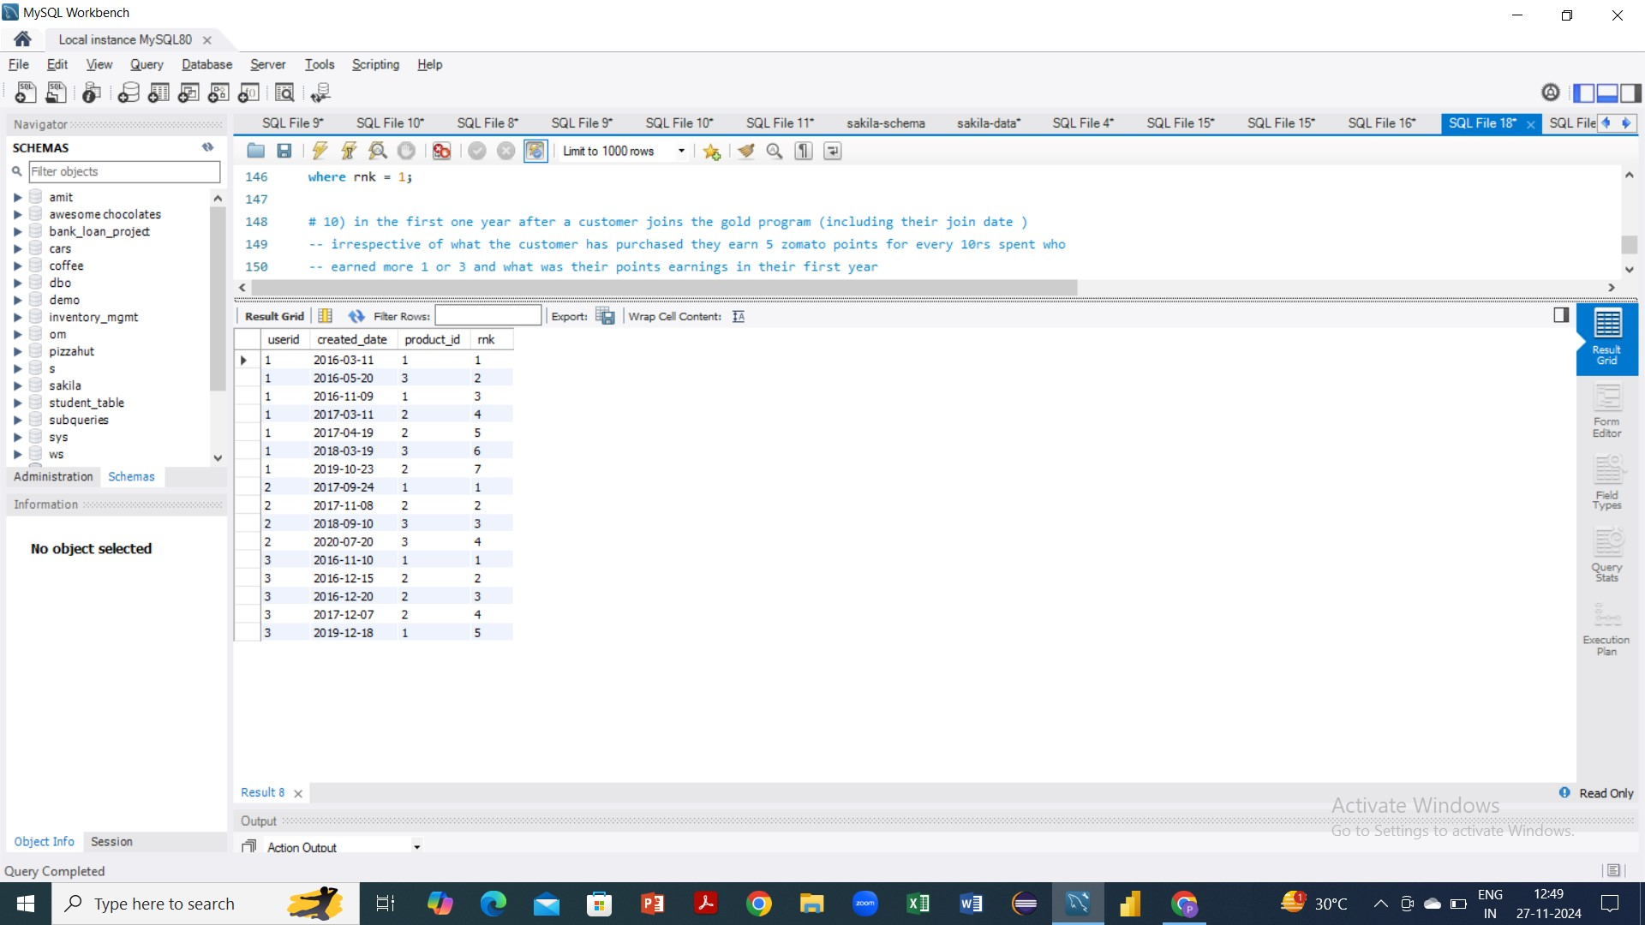

**w**

**a**

**s**

**t**

**h**

**e**

**i**

**r**

**p**

**o**

**i**

**n**

**t**

**s**

**e**

**a**

**r**

**n**

**i**

**n**

**g**

**s**

**i**

**n**

**t**

**h**

**e**

**i**

**r**

**f**

**i**

**r**

**s**

**t**

**y**

**e**

**a**

**r**

# THANK YOU!